Number the Stars: Final Discussion Lesson Reflection
Context: The Classroom
On October 8th, I taught the final lesson in a 5 lesson unit on the book Number the Stars. The lesson was given to a class of fifth graders at St. Columbkille, a private school in Dubuque, IA. I taught this specific lesson during my fifth week working with the class during an intermediate clinical field placement where I observed the classroom teacher’s instruction as well as teaching one to two lessons a twice a week. In the class there were 18 students of varying ability levels. Two of the students were on IEPs, and including these students 5 or 6 of the students were low performing readers. Additionally, 4 or 5 of the students were advanced readers.
In the first lesson, the students were given background knowledge on topics discussed in Number the Stars. This background information included material about World War II, the Holocaust, and other information related to the persecution of Jews by the Nazis. Some of the students already had some prior knowledge about these areas but it was very surface level. In addition to the information provided during the initial informational lesson, students were given access to texts that provided supplemental information on the topic.
Following the informational lesson, students were assigned reading in the book in 3-4 chapter groupings. Prior to reading the chapters, students were introduced to key vocabulary from the chapters and that would be used in discussion of the chapters. After students completed the readings, I taught 15-20 minute lessons on the chapters in the form of whole class discussions. The discussions included a review of the main events in the chapter, character development, questions students had about the chapters, and predictions on what would happen later in the book.
Rationale for the Lesson Objectives
For the lesson I had three main objectives tied to Common Core Standards. Each of these standards were chosen based on topics that had been introduced during prior discussions and extending standards I targeted in prior lessons in the unit. Additionally, these specific standards were chosen because they could be easily linked and built well upon one another within the context of the lesson.
The first part of the lesson was intended to review the content of the reading assignment and to get students thinking about the events of the text and terminology we learned in relation to the text in previous lessons. This information was necessary for students to draw the kinds of connections I wanted them to in relation to the two standards addressed in the group work completed later in the lesson. During group work and the following presentation and discussion, I sought to meet the objectives of “ CCSS.ELA-Literacy.RL.5.2 Students will determine a theme of a story from details in the text, including how characters in a story or drama respond to challenges or how the speaker in a poem reflects upon a topic” and “CCSS.ELA-Literacy.RL.5.3 Students will compare and contrast two or more characters, settings, or events in a story or drama, drawing on specific details in the text (e.g., how characters interact).”
Rationale for Lesson Strategies and Materials
The lesson was broken into three main parts. It began with a whole group discussion led by me. Then, students were divided into student run heterogeneous groups for the second part of the lesson in which the majority of me lesson objectives were met. Finally, students came back to a whole group lesson in which students shared the leading of the discussion with me and the classroom teacher.
The structuring of the lesson was intended to keep the students engaged by allowing them to gradually take on more control over the direction of the lesson as it progressed. I noticed in previous lessons that using instruction with only whole group discussion for longer periods of time tended to lead to the students losing interest. Therefore, by allowing chances for movement and smaller group work I was able to maintain student engagement for a longer period of time. Additionally, using student roles in the groups allowed for me to ensure that all students were taking a role in the discussion instead of having only one or two of the more advanced students run the discussion. Another benefit I found to the small groups was that it made it easier for me to guide them to deeper levels of thinking with their theme than I would have been able to if we had done these themes in a while class discussion. Therefore, while the students only examined one theme in their group, they reached a higher level of thinking with it and had the benefit of hearing peers’ higher level connections on other themes as well. One way that I could have improved this would have been to be more deliberate with which students took on what role. By randomly assigning roles, it was less efficient and led to some additional behavior management concerns over who was supposed to do what within the discussion.
By having the students return to whole class discussion after the group work, I was able to create more extensions for all students on the themes instead of just the students in the small groups. Additionally, by asking extending questions to the discussion I was able to check the understanding of some of the lower performing students who had taken that role as well as to challenge other students to think at a more inferential level and make deeper connections to my objectives for the lessons. However, I think this section of the lesson would have been more effective if the students had been asked to share 1 or 2 specific examples of their theme instead of answering questions about the theme. This is because during the time it took for six groups to present their theme, many of the students who were not presenting became disengaged.
Analyzing Teaching
Throughout the lesson, the students took an active role in answering and asking questions about the book. However, I think that if I had condensed my teaching points into two or three more meaningful questions during the initial whole group discussion, it would have been a more meaningful. It would have allowed me to make a better assessment of where students were at with the text, and more of an opportunity for the students to make connections between the chapters we read and the rest of the book.
During the group work section of the lesson, I thought several things went well. The structured notes sheet for the group discussion, made members of the group more accountable to stay on topic, which had been a problem in a previous lesson where students worked in small groups. Additionally, I spent a lot of time during the group discussions walking from group to group listening into their conversations and asking questions to extend the thinking on the theme to include more specific examples and to guide the students to further explore areas such as how comparing and contrasting different elements of the story, especially characters, could demonstrate the presence of their theme in the story since this was an outcome I wanted students to reach in the lesson.
Then, in the whole group presentations and discussion, I think the students did a good job of sharing what their group discovered about their theme which provided additional learning opportunities to their peers. All students also had the opportunity to answer questions that built on the information in the presentations which helped keep students who weren’t presenting engaged. However, overall keeping the students not presenting engaged was a bit of a challenge and I think it would have helped to have them take notes on important concepts or another activity to go along with the presentations so they didn’t lose interest in the activity.
Finally, I think that bringing in a student question from the group work, although not planned, allowed for an engaging way to end the lesson and lead into the final unit assessment activity. By having the students help answer the question of why codes were used in the book, which was an important theme we didn’t look at earlier in the lesson, provided a few different opportunities for me. First, as a class we were able to practice the theme evaluation that students did in small groups. Second, students were able to connect the background knowledge that we talked about at the beginning of the unit and in the opening whole group discussion of the lesson to the concept of themes. Third, it helped re-engage the students because it was a question a peer had brought up and so it gave them more ownership of the discussion.
Final Assessment Evaluation
The final assessment for this unit, that also served as my main assessment for the lesson as well, was one that was recommended by my cooperating teacher since she used it in previous years for the book. However, the content that I was looking for and the rubric used for grading were what I made up to go along with the activity.
The assessment was two part. In the first part of the assessment students created a picture panel. Eight chapters of the book were selected by my cooperating teacher and me. Students then had to illustrate and explain the main event in that chapter. Then, in the second part of the assessment students had to select five characters from the book and describe how they demonstrated the theme of heroism in the book. As can be seen in the examples below, the assessments showed me which students had a deeper grasp of the text and the outcomes, and if I were to continue teaching in the classroom would allow me to better target students for remediation or enrichment with the outcomes in future lessons.
The first part of the assessment did not directly relate to my outcomes for the final lesson, but was tied to my overall outcome for the unit which was to be able to read and comprehend grade level texts. Therefore, by having students identify and explain key events in chapters I was able to see if they were able to understand what occurred in the chapter and if they could evaluate which events were pivotal to the plot of the story.
The second part of the assessment was directly related to my outcomes for the final lesson. In this assessment, student not only had to find examples of characters who helped the author demonstrate the theme of heroism in the text, but they also had to indirectly compare and contrast how different characters showed this trait in similar or different ways. This helped me to see which students, like student B, really understood the theme and could highlight the different ways characters demonstrated it throughout the book, and which students, like student A, could use some more support to reach a deeper understanding of the concepts.
Assessment Examples
Figure 1 Student A's Heroism Response
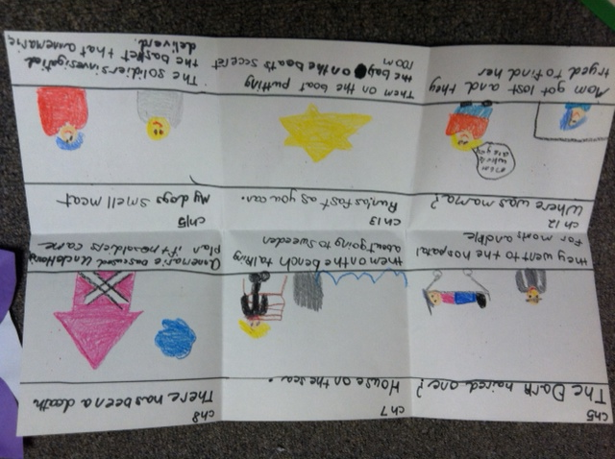
Figure 2 Student A's Key Events Panels
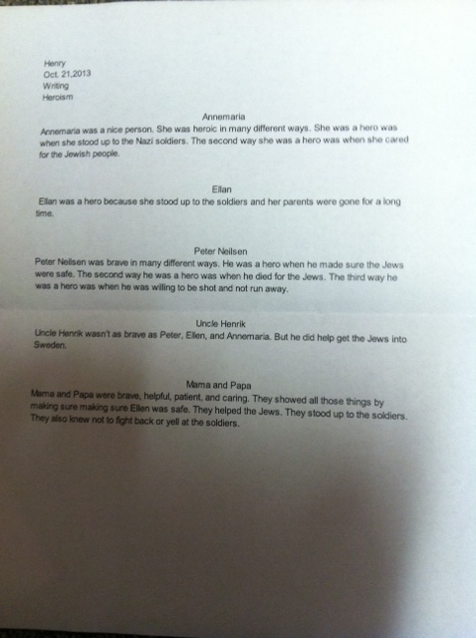
Figure 3 Student B's Heroism Response
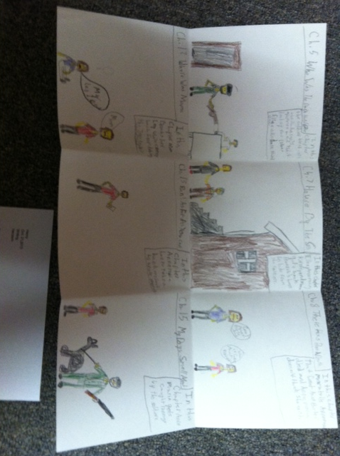
Figure 4 Student B's Key Event Panels

