Why do krill look like a pink cloud?
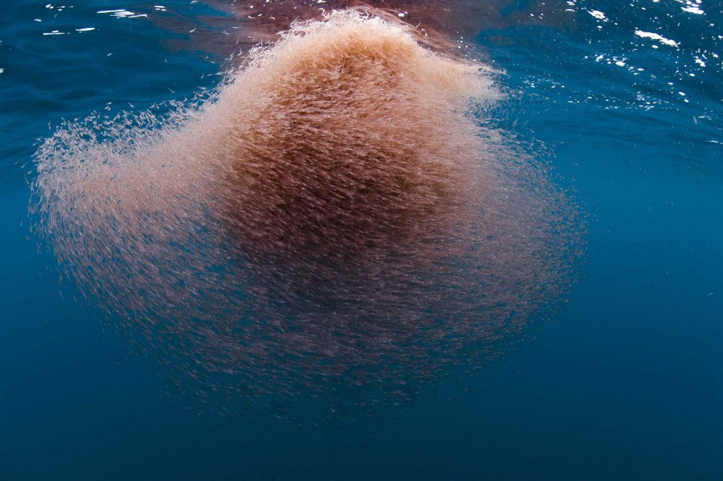
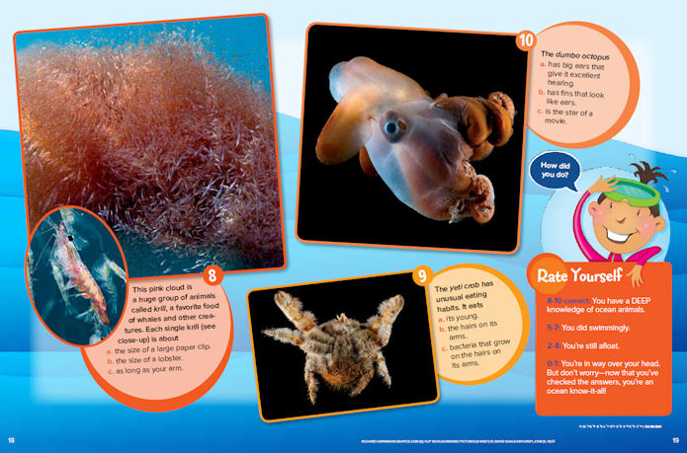

Which is bigger a killer whale (orca) or a hump back whale?
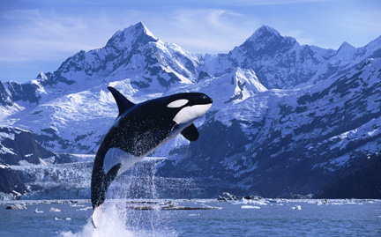
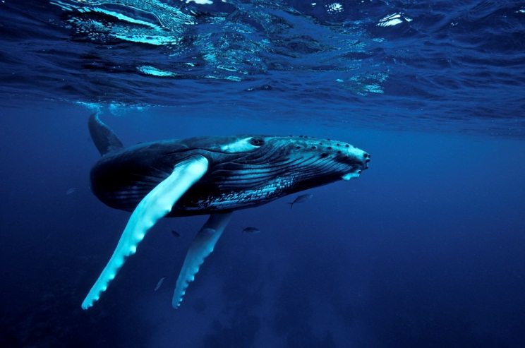

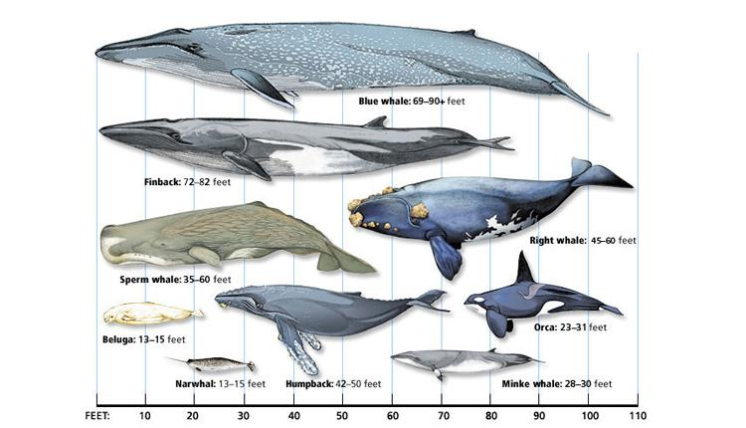

Why do orcas eat other sea animals?
Killer Whales diet includes fish, squid, seals, sea lions, walruses, birds, sea turtles. otters, penguins, polar bears, reptiles, sharks, octopus and even smaller whales. However the feeding habits of Killer whales will depend on the place they are inhabiting at a particular time.
Killer whales eat about 500 pounds of food each day. Therefore, up to 60% of their time can be spent to get food.
http://www.killer-whale.org/what-do-killer-whales-eat/
How Far is Antarctica from the US?
Distance between United States to Antarctica:
km = miles

Is there a plant called a seal?
Solomon's Seal (polygonatum biflorum) is a medicinal herb that has diverse healing properties. It can be used as a herbal tincture (best use), salve, tea or supplement.
http://www.solomonsseal.net/abouttheplant.html

